Want to become a superhero?  
- Shreshtha Jain, BVCOE  
  
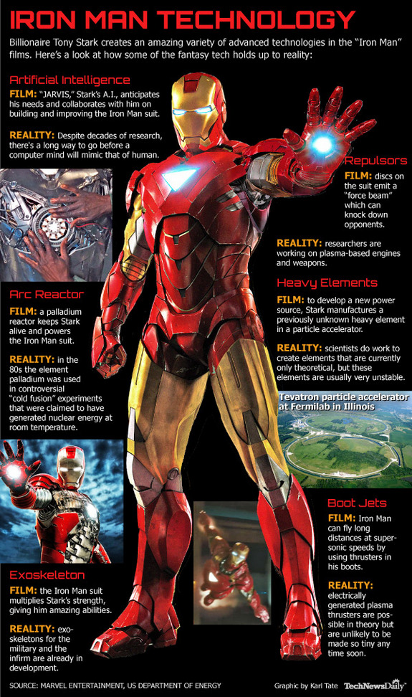

Have you ever tried to climb the walls like a ‘SPIDERMAN’ or found yourself boasting about your very own bulletproof ‘IRONMAN’ suit? A sound sleep with ‘sweet dreams’, wasn’t it? Well, it is not a dream anymore. Troy Hurtubise’s latest invention, ‘The Trojan S Series’ is a protective suit of modern armor i.e. the Ironman. Hurtubise claims that the suit, which is just weighing 13.6 kilograms, can withstand gunshots from a very close range and is light and flexible, making it easy to run, climb and drive in. This was made possible because of the ballistic grade protective panel which he invented and used in the Trojan Suit. This panel is able to deflect twelve bore shots and knives. So if you want to become the next Ironman you will *just* have to pay £35,000! But if you are not really interested in the Ironman, you can rather glide over the Gotham city like our own ‘BATMAN’. The ‘Gryphon’, having a wingspan of 1.8 meters and weighing 30 kilograms, is made up of light and durable material like carbon fiber. It can cruise for 50 kilometers and when pointed downwards, the Gryphon can reach to a terminal velocity of 250 miles per hour, fast enough to dodge away the Joker’s bullet easily. Designed and developed by Spelco, the Gryphon costs around £ 10,300. Unfortunately if you or your kids want to become the next Spiderman, you will just have to wait a little. Keeping in mind the pace at which modern technology supersedes itself, it won’t take very long. A wave of robots is in development that would climb vertical surfaces by using the phenomenon of induced electrostatic attraction, which is induced between the climbing pad and the surface it touches. Switching off and on the current allows the pads to move. Current prototypes can carry up to 34 kilograms of weight and according to Nicola Pugno, who is currently working on the man version size of this robot, there is no fundamental reason that why can a robot not carry 90 kilograms of weight.   
Transforming dreams into reality, today’s technology can turn you into any superhero you want. So all the fans get ready to become the next superhero and save your city! Needless to say, with great power, comes great responsibility.

